
This is to certify

has successfully completed the Elder’s Leadership Certification
Month –Date -Year

ELDER’S LEADERSHIP CERTIFICATE

Conference Ministerial
Dr. Ivan Williams, North American Division Ministerial
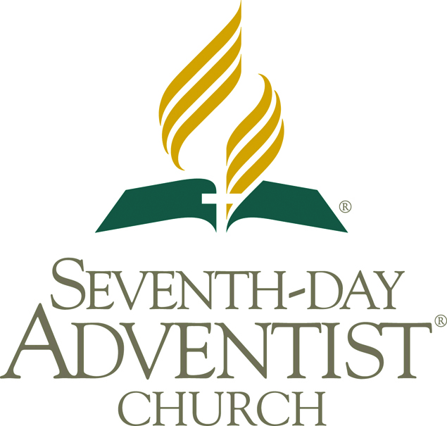
NORTH AMERICAN DIVISION OF THE SEVENTH-DAY ADVENTIST CHURCH



