To Whom It May Concern,

I am desirous of a ministerial position where I can demonstrate my training and skills as a Pastor called by God. I have been brought up in this church and born into a family which humbly gives me the benefit of being a fourth generation Seventh-day Adventist. God has blessed me with the passion to preach, teach, worship and administrate. I personally love to facilitate in the spiritual development and growth of young adults, and get excited whenever people join the family of God.

In recognizing the calling on my life, the Lord ordered my steps to attend Oakwood University. While I was there I have acquired unforgettable experiences in evangelism, and was able to contribute to the growth of the church. These experiences took me to the Inter-American Division, Southern Africa-Indian Ocean Division and of course the North American Division. As a result, I lead evangelistic meetings and revivals which gave me the ability to refine my gifts in preaching and teaching. My most memorable experience was when I went to Jamaica. I was there preaching a five-week series in the Northeast Jamaica Conference. It was through that endeavor that I grew a stronger passion for evangelism and church growth. While I was there, God personally confirmed the work that He was doing in and through me. I have been ordained as an Elder, and I am also musically inclined being gifted in singing and leading worship and praise. In being faithful to the call the Lord continued to lead me to pursue a Masters in Divinity at Andrews University where I have just graduated. While there, I remained active in the gospel ministry, the Lord continued to refine and teach me many things concerning myself for the purpose of spiritual growth and to become a sharper tool for God's honor. Remaining in a posture to continually learn of God, these experiences has given me the adequate preparation to serve as a productive Pastor.

Feel free to contact me at 347-415-5532 for any further questions. Thank you for your consideration.

Respectfully yours,

Fresnel Fanfan II

Fresnel Fanfan, II
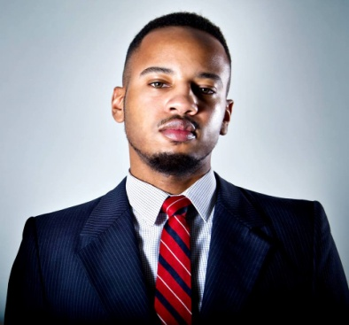
9766 Rosehill Rd, Apt M5
Berrien Springs, MI, 49103
347-415-5532
Fresnel7@gmail.com
Profile

Communicator and teacher with a strong work ethic; dedicated to finding solutions and developing resources for effective ministry that will aid in the growth and development of God’s people.
Education

Oakwood University – Theology, Bachelor of Arts
Graduated May 2012
Andrew University – Masters of Divinity, graduation May 2015
Evangelism Experience
ShareHim (Barkly SDA), May 15-31, 2011 Mauritius, Africa
- Evangelist, Preached nightly for two weeks

Voices for Haiti (Cabaret SDA), July 13-20, 2010 Haiti, WE
- Evangelist, Preached nightly for the “Voices for Haiti” Youth Week Revival

Northeast Jamaica Conference, July 8-Aug. 11, 2009 Jamaica, WE
- Co-Evangelist, Preached for five weeks at the “Preparing to Meet Your God Crusade” and alternated nights with my co-evangelist

Flatbush SDA, July 22-August 5, 2008 Brooklyn, New York
- Assistant Evangelist for the “Listen to Your God Crusade,” Worship Leader, Preacher
Ministry Experience

Field School, July 23- August 22 2015 Euclid, Ohio
- Tutelage under Dr. Myron Edmonds, Performed Bible studies for baptismal candidates and new believers, Home visitations

Goshen SDA, January 2014-Present Chicago, Illinois
- Assistant Pastor over Worship and Praise, Coordinates worship and events, Works with church as a whole

Kingsboro Temple SDA, Year 2000-Present Brooklyn, New York
- Current church membership-engaged with the church as a whole, Pathfinder member, choir member, preached and participated on the platform.

Madison Mission SDA, January 2006-May 2011 Huntsville, Alabama
- Ministerial Extern & Elder in Training, Lead in the small groups and Sabbath school departments, participated on the platform and board meetings

New Life SDA, June 27-July 25, 2010 Lake City, South Carolina
- Bible Worker/Worship Leader, Coordinate Bible studies and lead worship every night at the revival

South Central Conference SDA, June 17-August. 2, 2009 Birmingham, Alabama
- Literature Evangelist, Solicit and organize Bible Studies, give Christian literature on a donation basis

Shiloh SDA, Dec. 16-22, 2008 Brooklyn, New York
- Speaker/Planner, Aided in planning nightly services and preached one of the nights for the “Blizzard Revival”
Additional Skills
- Ordained Elder
- Praise and Worship Leader
- Speaks French and Haitian Creole

